Step1 : Create Private github repositories repo1 repo2 repo3 respectively.

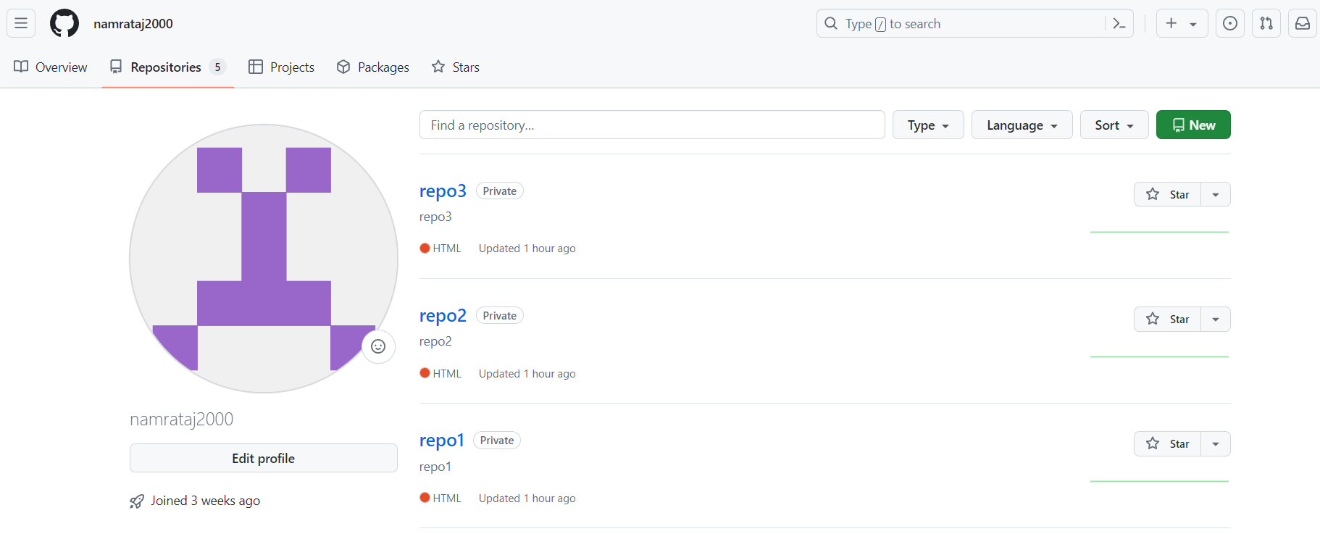

Step 2: commit index.html file in repo1 repo2 repo3

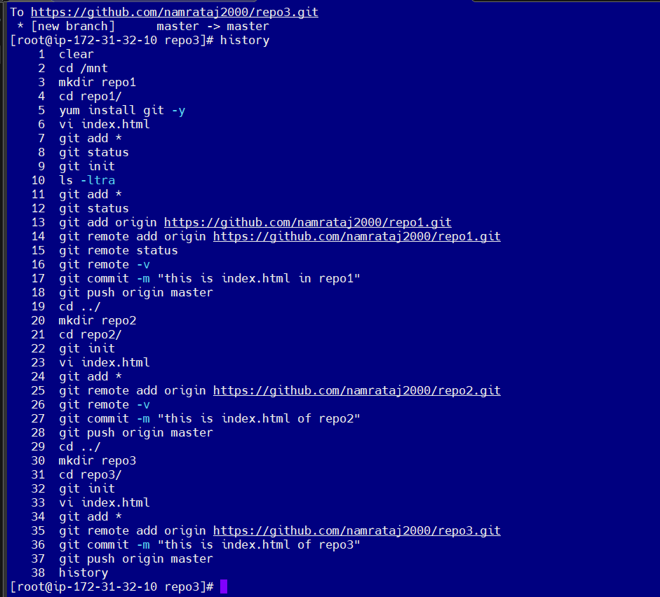

Step 3: Setup Jenkins credentials:

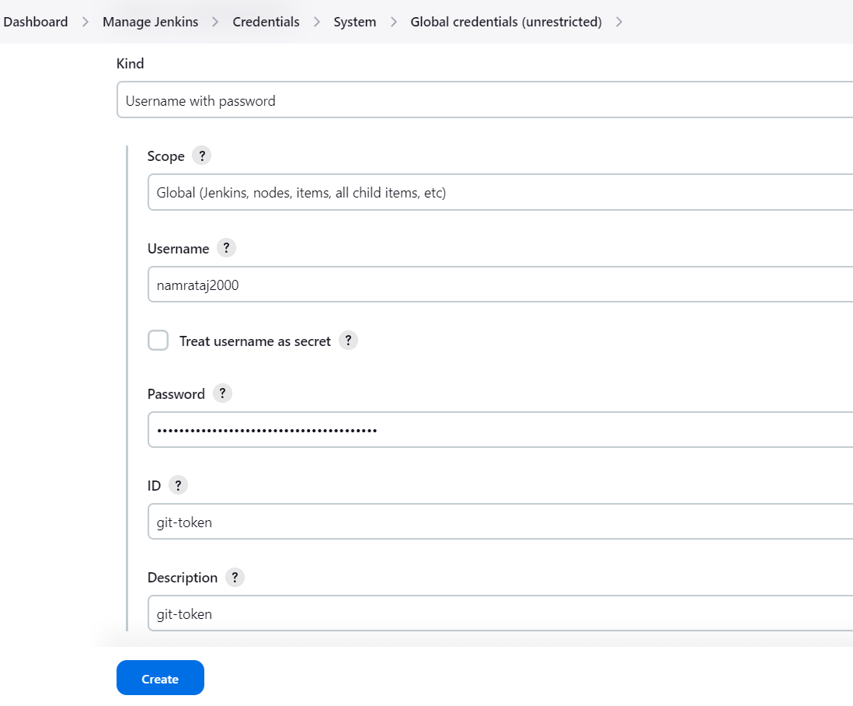

Step 4 : create Jenkins jobs :

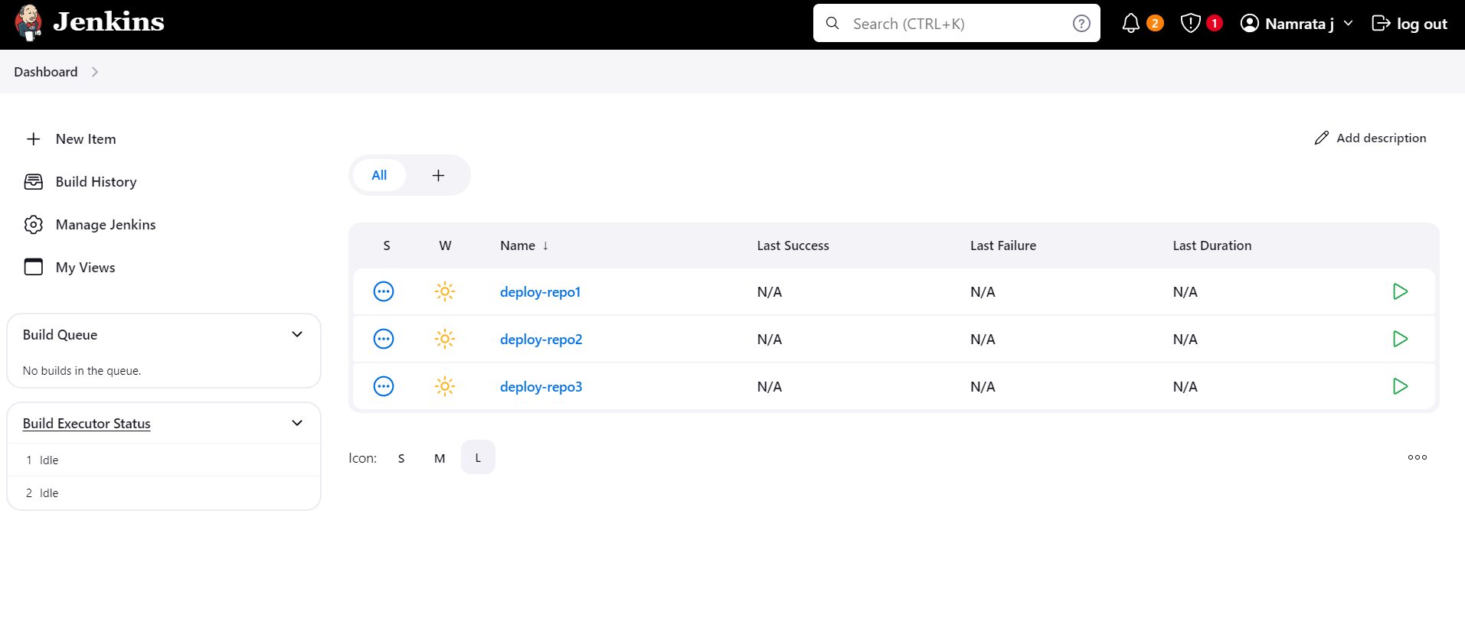

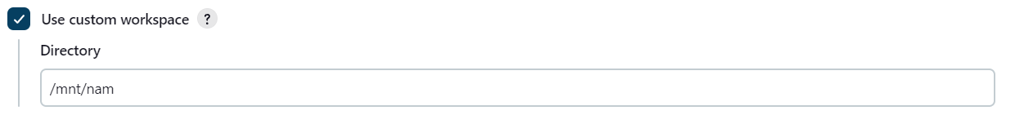

Step 5 : Write Shell Script:

1. Defined two local variables
2. Created parent directory in /mnt/namrata/repo1
3. Copy index.html to destination folder

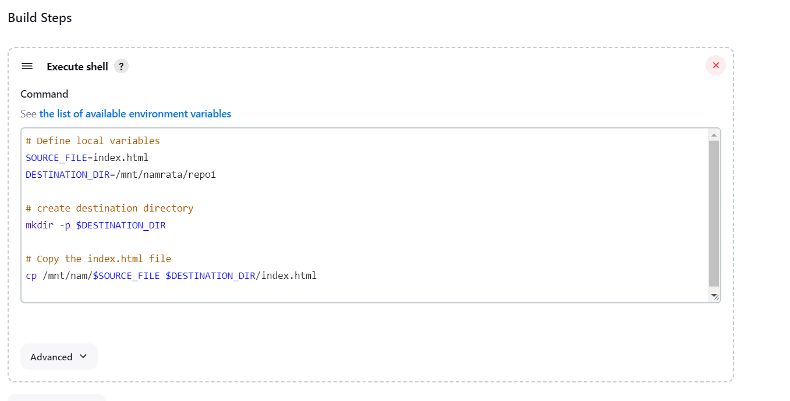

Step 6 : Build the jobs :

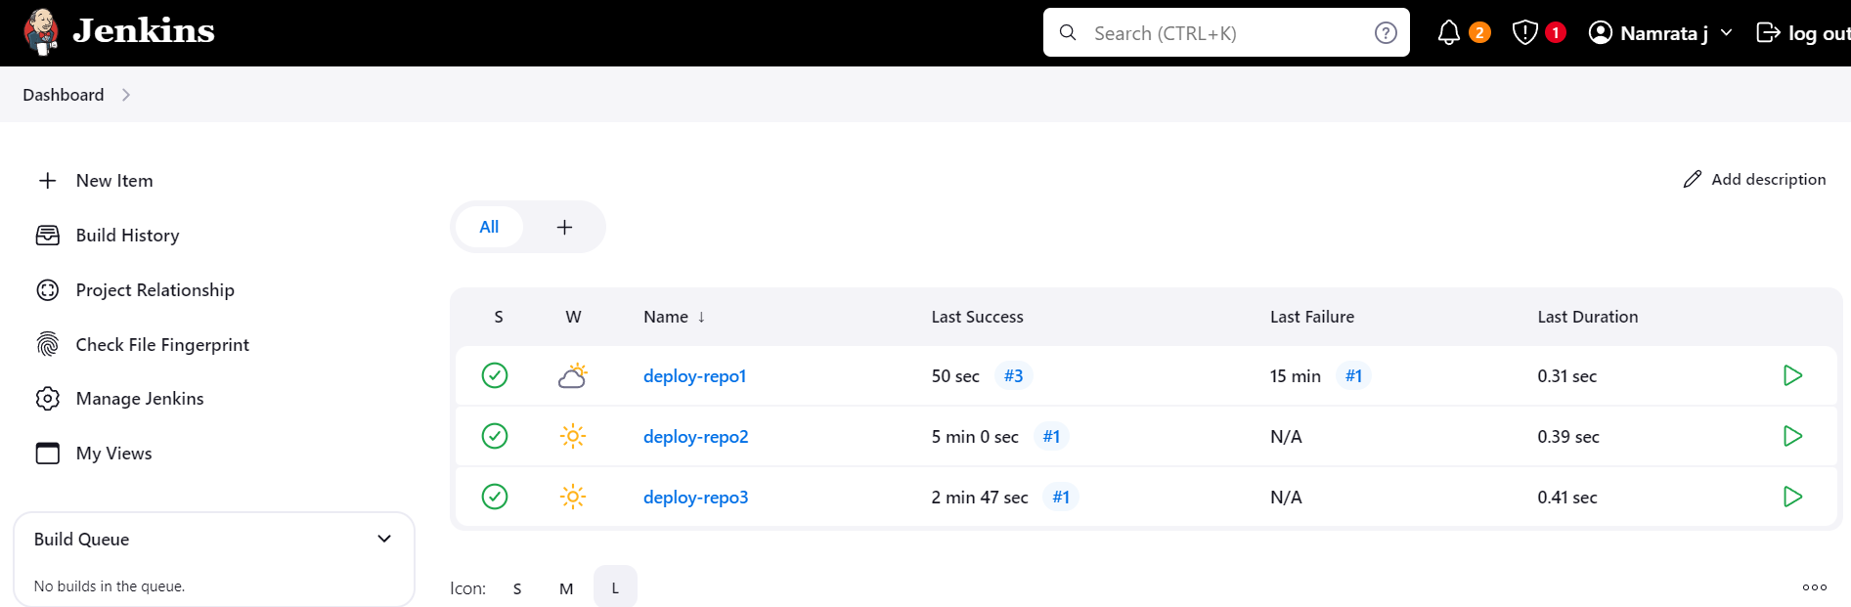

Output :

